Employee Management System project PostMan output details

Name: Hanna Sharma
Registration No. 12311538

POST request:
Add an Employee with their name, age and designation:
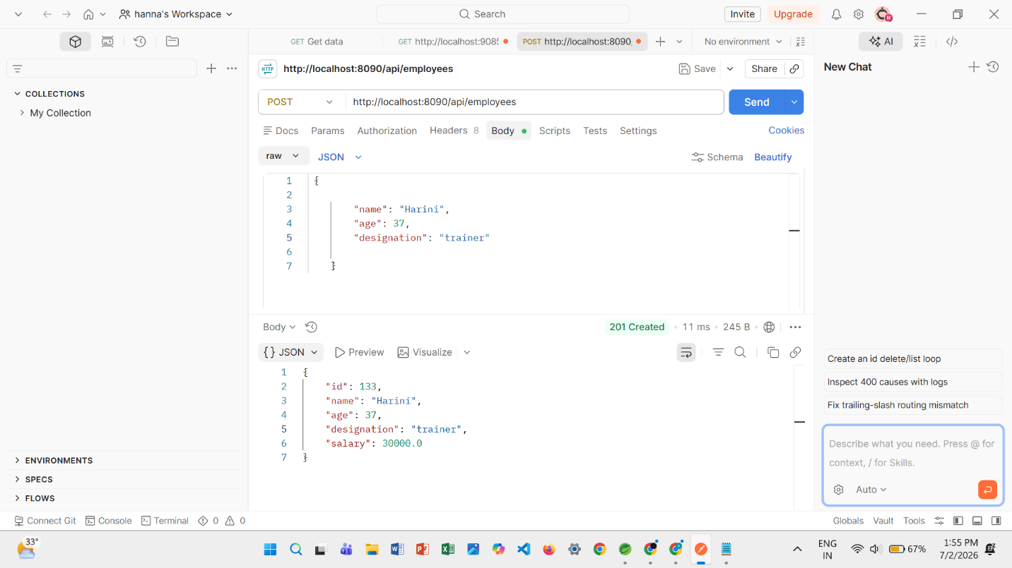

GET request: Retrieves all employee details from the Employee List table of the application.
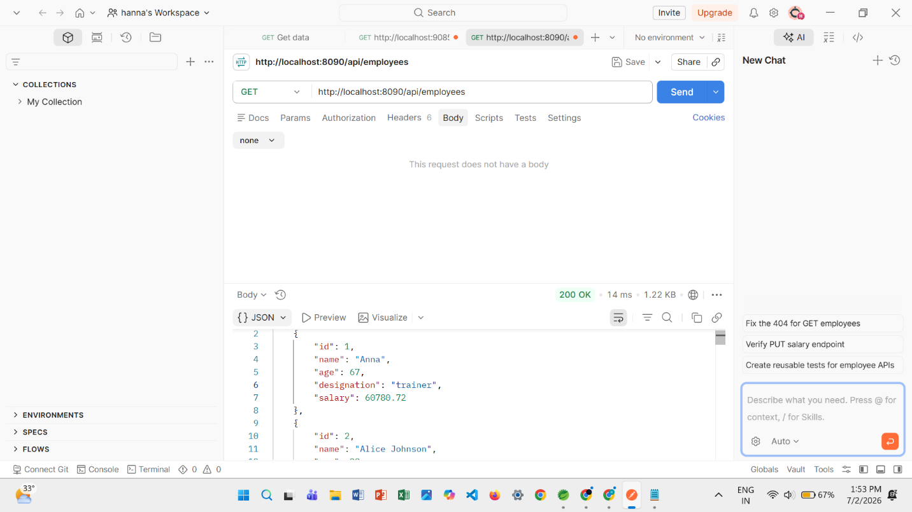

PUT request to increase salary of a certain employee using his ID:
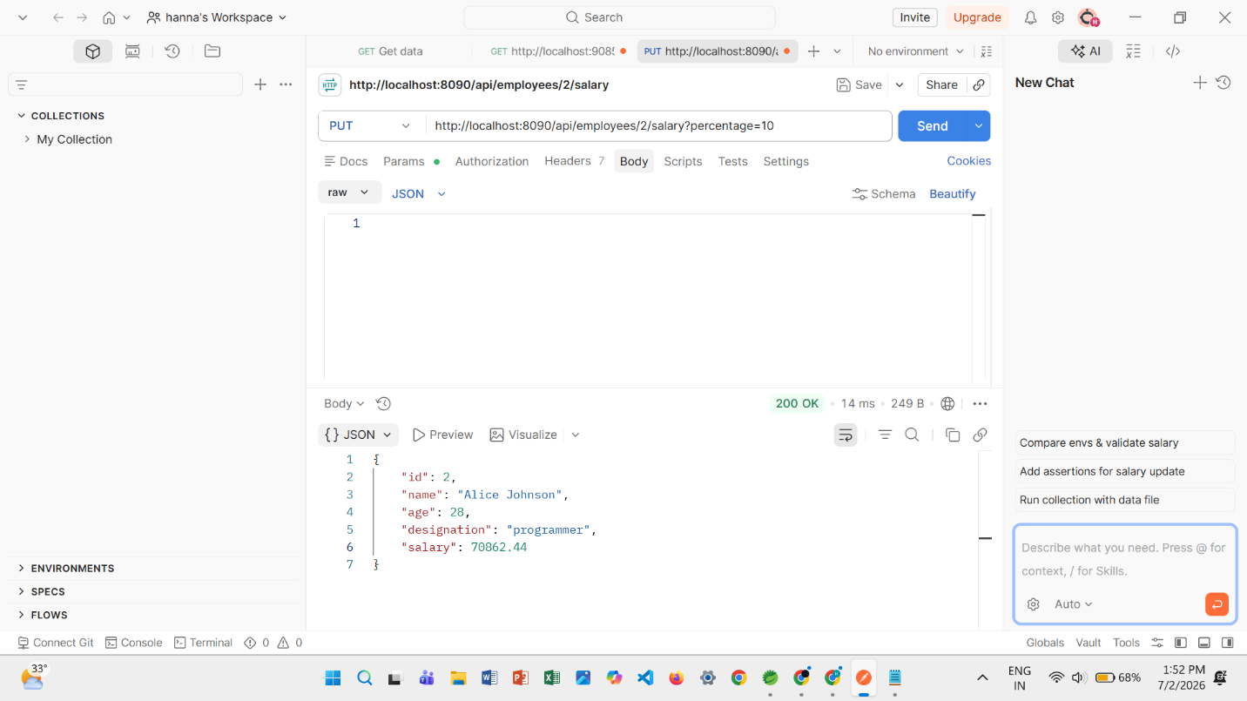

Invalid input testing:
